

Social Security Administration
FY 2017 Strategic Sustainability Performance Plan

June 30, 2017

Point of Contact:
Leslie Ford
leslie.ford@ssa.gov
410.594.0111

Table of Contents
(Uses Table of Contents function in Word. Use “update table” to automatically update page numbers)

Policy Statement 3
Executive Summary 4
Agency Progress and Strategies to Meet Federal Sustainability Goals 9
Goal 1: Greenhouse Gas (GHG) Reduction 9
Goal 2: Sustainable Buildings 12
Goal 3: Clean & Renewable Energy 16
Goal 4: Water Use Efficiency & Management 18
Goal 5: Fleet Management 20
Goal 6: Sustainable Acquisition 23
Goal 7: Pollution Prevention & Waste Reduction 26
Goal 8: Energy Performance Contracts 28
Goal 9: Electronics Stewardship & Data Centers 30
Goal 10: Climate Change Adaptation and Resilience 33
Appendix A – Fleet Management Plan & Vehicle Allocation Methodology 35
Appendix B – Multimodal Access Plan 42
Appendix C – Acronyms and Units 45

Policy Statement


The Social Security Administration (SSA) touches the lives of virtually every person in America. We run one of the Nation’s largest entitlement programs, as well as the Supplemental Security Income program that provides financial support for aged, blind, and disabled adults and children with limited resources. While fulfilling our mission to provide economic security to many individuals, we will continue our history of promoting a clean energy economy, environmental leadership, and sustainability. We will work cooperatively with other Federal, State, and local governments to promote sound environmental management practices, while providing a safe and healthy work environment for our employees.

We are pleased to publish this Strategic Sustainability Performance Plan, which provides our agency with a structured, systematic approach for managing environmental and regulatory responsibilities to continuously improve overall environmental stewardship.

To promote environmental stewardship, our officials will:
- Comply with all environmental and energy-related statutes, Executive Orders, and any applicable Federal, State, and local regulations.
- Consider environmental aspects when making planning, purchasing, operating, and budgetary decisions.
- Continue our employee awareness campaign to educate and encourage employees to reduce energy consumption and water usage, reduce the amount of waste produced, and promote re-use and recycling whenever possible.
- Continue improving environmental stewardship by setting environmental goals, measuring progress, taking corrective action, when necessary, and communicating the results.
- Incorporate climate change and adaptation considerations in our agency operations.
- Communicate and reinforce this policy throughout the agency.

We are pleased to promote environmental leadership and sustainability at SSA.

Chris Molander
Chief Sustainability Officer

Executive Summary
Vision
With our mission to provide economic security to many individuals, sustainability is an integral part of our success. It enables us to do our jobs more cost-effectively and be responsible stewards of the health of our employees, the public we serve, and the environment in which we all live. We have already made great strides integrating sustainability into the day-to-day implementation of our mission, but there is much more we can do. We are committed to further improvement through a range of approaches, such as increasing the efficiency with which we use energy and water in our buildings, reducing solid waste disposal through recycling, and decreasing the combustion of petroleum-based fuels in our vehicles, while increasing the percentage of electric and hybrid vehicles in the agency’s fleet. In addition, the choices we make in acquiring products and services play a critical role in promoting sustainability, and we are committed to continuing our acquisition processes with sustainability as a priority. Our stewardship for electronics goes beyond acquisition. We will continue to ensure our computers and monitors use minimal energy and are disposed of in an environmentally-sound manner. Finally, sustainability goes hand-in-hand with building resilience to the impacts of climate change. We will work to identify our vulnerabilities to climate change and address them proactively.

Leadership
The Associate Commissioner, Office of Facilities and Logistics Management is the Chief Sustainability Officer (CSO) and the Climate Change Adaptation contact for the agency. The CSO reports directly to the SSA Commissioner. The performance plans for appropriate senior staff include specific measures related to sustainability.

Performance Review
Goal 1: Greenhouse Gas Reduction
Our Scopes 1 and 2 greenhouse gas (GHG) emissions in fiscal year (FY) 2016 were 50.6 percent lower than the FY 2008 baseline, as determined by our annual GHG inventory. Scope 3 GHG emissions in FY 2016 were 25.6 percent lower than the base year. The vast majority of our emissions come from just two sources: employee commuting and purchased electricity. Due to commuting, Scope 3 emissions account for 69 percent of our total GHG inventory.

We have made notable progress reducing the environmental impact of employee commuting. After reaching agreement with our unions to expand our telework program, in December 2013 we issued a new telework policy. As a result, the number of employees who teleworked regularly increased by 77 percent from FY 2014 to FY 2015, accelerating the decline in our commuting emissions. Purchased electricity makes up 83 percent of our Scope 1 and 2 emissions (before renewable energy is subtracted out), which emphasizes the need to improve energy efficiency in our buildings. To this end, we will continue to actively implement improvements, such as installing advanced meters and awarding energy savings performance contracts (ESPCs).

Goal 2: Sustainable Buildings
The General Services Administration (GSA) delegated responsibility to us for reporting on Federal sustainability requirements for our headquarters (HQ) campus and eight other facilities across the country. In FY 2016, these delegated facilities exceeded the 2.5 percent reduction in energy intensity (Btu/square foot) from the FY 2015 baseline, achieving a 9.4 percent reduction. We will strive to continue our strong progress on the goal of Executive Order (EO) 13693 for energy intensity in FY 2025 to be 25 percent lower than in FY 2015, through efforts such as light-emitting diode (LED) testbeds, energy audits, ESPCs, and using building data to improve energy performance. In accordance with EO 13693, we aim for 15 percent of our delegated gross square footage to comply with the Guiding Principles for Sustainable Federal Buildings by FY 2025.

Goal 3: Clean and Renewable Energy
Renewable energy sources supplied 22.7 percent of our total electricity in FY 2016, exceeding the goal of 10 percent. Most of this comes from renewable energy certificates (REC), although we also generate renewable energy on-site in five locations. Four are photovoltaic (PV) arrays that accounted for more than 2,111 megawatt-hours (MWh) of electricity. This number increased significantly over FY 2015 thanks to the new array at the National Security Center. The other location is a small wind turbine that generates less than 1 MWh per year. RECs will remain the primary strategy in achieving our goals for clean and renewable energy. 16.8 percent of SSA’s total electric energy comes from clean energy, exceeding the 10 percent goal for FY 2016.

Goal 4: Water Use Efficiency & Management
We are proud to have greatly exceeded the FY 2015 goal of 18 percent water intensity reduction, with a reduction of 49 percent, as shown in Figure ES-1. We are already below the FY 2025 target, but will continue to pursue measures that reduce our water intensity and maintain efficient practice for the use of water. All delegated facilities are metered for both potable and irrigation water consumption.
Figure ES-1: Potable Water Intensity Reductions and Future Goals

Goal 5: Fleet Management
The amount of alternative fuel used by our fleet in FY 2016 reached more than 13.9 percent of total use, representing an increase of 1,384 percent since FY 2005, far exceeding the Federal goal of 159.4 percent.
EO 13693 replaced the fuel-based goals with a new fleet performance metric: GHG emissions of the fleet per mile driven, relative to an FY 2014 baseline. Our FY 2016 GHG emissions per mile traveled were 3.4 percent lower than in FY 2014. Our main path to reaching the FY 2017 goal of a 4 percent reduction is to increase the number of electric and plug-in hybrid vehicles in the fleet. However, we will also install Category II telematics in agency vehicles, continue right-sizing and optimizing our fleet, and continue using the GSA Fleet Drive-Thru management system.

Goal 6: Sustainable Acquisition
We conducted 100 percent of our acquisitions sustainably in FY 2015, as determined from our quarterly reviews of 5 percent of applicable new contract actions (53 actions). All applicable new contract actions reviewed met Federal mandates for acquiring products that are energy efficient, water efficient, biobased, environmentally preferable, non-ozone depleting, recycled content, or non-toxic or less toxic alternatives, where these products meet performance requirements. This success was possible due to the rigorous system we have in place to assure sustainable acquisition and ongoing efforts at continuous improvement. EO 13693 requires SSA to set an FY 2018 target for biobased purchasing, and our target is 21 contracts and $4,143,000 in biobased products to be delivered.

Moving forward, we will continue to hold quarterly sustainable acquisition reviews and semi-annual acquisition management reviews. We will also ensure that the appropriate Federal Acquisition Regulation (FAR) clauses are included during our regular quarterly contract reviews and biannual acquisition management reviews. We will continue to report sustainability compliance in the Contractor Performance Assessment Reporting System (CPARS), and will update our CPARS guidance for contracts-related staff to include sustainability compliance as an assessment factor, where applicable.

Goal 7: Pollution Prevention & Waste Reduction
In FY 2016, we used recycling to divert more than 56 percent of our solid waste away from the waste stream, exceeding the goal of 50 percent. In FY 2016, we implemented our waste minimization and chemical storage plan which will work on an ongoing basis to reduce the quantity of chemicals at the main campus. We will ensure that all new contracts involving hydrofluorcarbons (HFCs) include a requirement for the contractor to document quantities, and we train all personnel who work with heating, ventilation and cooling (HVAC) equipment on the use of HFC recycling equipment.

Goal 8: Energy Performance Contracts
We exceeded our commitments made under the President’s Performance Contracting Challenge, awarding $20.4 million in performance-based contracts by the end of calendar year (CY) 2016. Our target for FY 2018 is $11 million. We initiated a utility energy service contract (UESC) to enhance the efficiency of the HVAC systems at our Frank Hagel Federal Building in Richmond, California. We have already satisfied all performance contracting commitments, but we will continue to use ESPCs/UESCs to improve energy efficiency across our delegated facilities, when determined to be cost-effective.

Goal 9: Electronic Stewardship
We scored green in all categories of electronic stewardship, with 100 percent compliance on all required goals. We will continue to ensure that 100 percent of purchased desktop computers, laptops, and monitors are Energy Star or EPEAT-registered, ensuring compliance via quarterly compliance reviews. To ensure our continued use of power management features on all desktop and laptop computers, we will continue to use our comprehensive reporting and auditing compliance system. We ensure the environmentally sound disposal of all excess or surplus electronic products on an ongoing basis through our policies and procedures, which allow disposition only through GSA Xcess, CFL, Unicor, or a certified recycler. As the first Federal agency to volunteer for the Better Buildings Challenge of DOE and the White House Council on Environmental Quality (CEQ), we are committed to metering 100 percent of our data centers and ensuring that power usage effectiveness (PUE) is less than 1.4, server utilization and automated monitoring are at least 65 percent, and facility utilization is more than 80 percent.

Goal 10: Climate Change Resilience
While the scope, severity, and pace of future climate change are difficult to predict, it is clear that potential changes could have an impact on our operations and programs. Through climate adaptation planning, we are identifying how climate change is likely to affect our ability to achieve our mission, operate our facilities, and meet our policy and program objectives. We are working to improve our resiliency by tapping into inter-agency Federal Government initiatives to improve the accessibility and coordination of climate change science for decision-making, and we will continue to coordinate with the GSA’s climate change adaptation efforts. We will build resiliency into our policies and procedures by reviewing, on an ongoing basis, existing emergency contingency plans and workforce protocols and policies, and incorporating climate change considerations into them, as needed.

Narrative for Government-wide and Cross-agency Initiatives
SSA has been very successful in implementing performance contacting across its delegated facilities, and our success in the President’s Performance Contracting Challenge is detailed below. SSA coordinates its climate change adaptation planning with Federal government initiatives to ensure its approach is in line with other efforts. To increase the sustainability of our delegated facilities, we coordinate with GSA prior to any new construction or renovations to incorporate green building principles in an effort to make our buildings compliant with the Guiding Principles. SSA also participates in metering studies with GSA to evaluate the energy efficiency opportunities metering may create.

Progress on Administration Priorities
President's Performance Contracting Challenge
We committed to $20 million in contracts awarded by the end of CY 2016 under the President’s Performance Contracting Challenge. To date, we have awarded $20.4 million, and our cumulative commitments total $49.2 million. Our target for FY 2018 is $11 million. We have proposed a UESC performance contract (July 2017) in the Frank Hagel Federal Building (FHFB) in Richmond, California. This contract includes installing two energy efficient chillers ($7 million) and ten energy efficient air handler units ($4 million).

Electric and Zero Emission Vehicles
At all of our delegated facilities, we will assess the level of interest in charging stations for employee vehicles, and whether interest is for unmetered level-one charging or faster electric vehicle (EV) charging. We will assess the staffing time required to enforce parking restrictions at the charging stations, and we will determine if the stations will be installed and operated by SSA or an outside contractor.

We have some existing charging infrastructure in place and planned. The HQ campus has two EV charging stations, however, until a policy is in place for employees to use them, they are available only to fleet vehicles at this time. At our main data center, the National Support Center, the wiring has been completed for charging stations that will allow us to travel in EVs from our HQ in Baltimore to the data center, charge the vehicles while doing business, and have enough charge to return to HQ. Our Frank Hagel Federal Building in Richmond, California has charging stations powered by PV on carports.

Climate Preparedness and Resilience
To address the potential need to strengthen our programs, policies, and operations for resilience to climate change, in 2014 we conducted a survey of our delegated facilities regarding local weather-related problems facilities have already experienced; concerns facilities have for the future (including due to climate change); and facility contingency planning to address potential hazards. The responses identified a number of issues, including flooding, wildfire, and power outages. However, we also determined from the survey that the formal contingency processes in place in these facilities have them well prepared for weather-related problems, fire emergencies, and diseases that are pandemic, infectious, and/or communicable. To ensure that this continues to be true in the face of climate change, we will review all contingency plans, such as Continuity of Operations Plans (COOPs), during their regular review cycle to keep them current as changes to the operational environment occur, or are anticipated to occur. Examples of adjustments due to climate change include human health and safety impacts, such as unsafe air quality, unsafe heat index conditions, dangerous conditions from severe storms, and new disease threats due to an expanded range of vector borne diseases into the U.S. We have provisions in place to ensure the continuity of web-based services in the event of disruptions to the electrical grid, which is essential to make our services available online for customers with mobility or health issues.

We will prepare our next Climate Change Adaptation Plan once the next quadrennial National Climate Assessment is issued in 2018 or 2019.

The size and scope of our operations are conveyed in Table 1.

Size & Scope of Agency Operations

Agency Size and Scope | FY 2015 | FY 2016
Total Number of Employees as Reported in the President's Budget | 65,852 | 64,066
Total Acres of Land Managed | 0 | 0
Total Number of Buildings Owned | 0 | 0
Total Number of Buildings Leased (GSA and Non-GSA Lease) | 1,562 | 1,558
Total Building Gross Square Feet (GSF) | 29,498,485 | 29,329,420
Operates in Number of Locations Throughout U.S. | 1,562 | 1,537
Operates in Number of Locations Outside of U.S. | 0 | 0
Total Number of Fleet Vehicles Owned | 4 | 4
Total Number of Fleet Vehicles Leased | 454 | 447
Total Number of Exempted-Fleet Vehicles  (Tactical, Law Enforcement, Emergency, Etc.) | 3 | 2
Total Amount Contracts Awarded as Reported in FPDS ($Millions) | $1,638 | $1,496

Agency Progress and Strategies to Meet Federal Sustainability Goals
This section provides an overview of progress through FY 2016 as reported by agencies through the OMB Scorecard process on sustainability/energy goals and agency strategies to implement Executive Order 13693, Planning for Federal Sustainability in the Next Decade.

Goal 1: Greenhouse Gas (GHG) Reduction

Scope 1 & 2 GHG Reduction Goal
E.O. 13693 requires each agency to establish a Scope 1 & 2 GHG emissions reduction target to be achieved by FY 2025 compared to a 2008 baseline. The Social Security Administration’s 2025 Scope 1 & 2 GHG reduction target is 55%.

Chart: Progress Toward Scope 1 & 2 GHG Reduction Goal
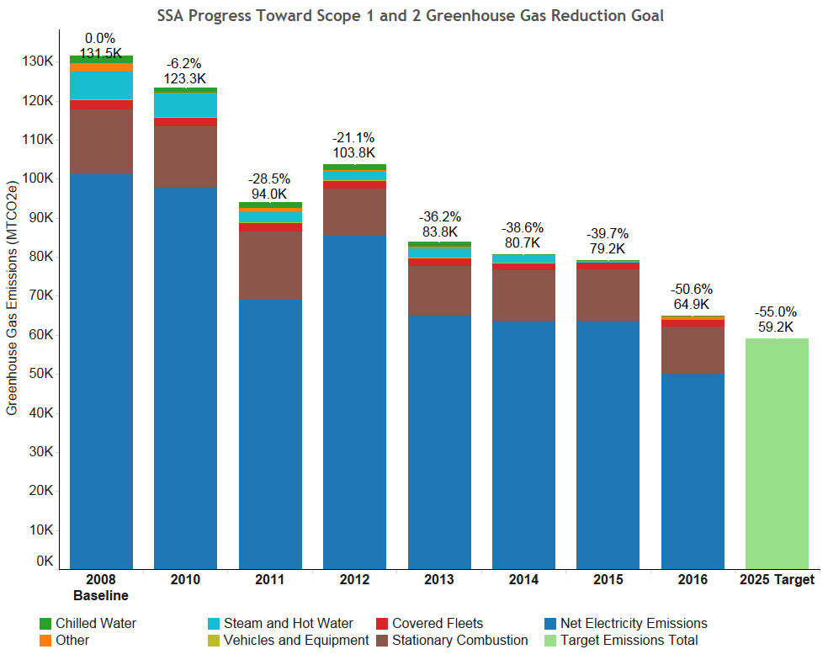
SSA is proud to have received all green scores for the 2016 Scorecard, and we are on track to meet the 55 percent energy reduction by 2025. We reduced Scope 1 & 2 emissions by 50.6 percent. We will continue implementing improvements to our facilities and fleet, while increasing the renewable energy to achieve our goal of reducing Scope 1 and 2 emissions by 55 percent by FY 2025.

Scope 1 & 2 GHG Reduction Strategies for Fiscal Year 2018
Strategy | Strategy Narrative | Targets and Metrics
Use the Federal Energy Management Program (FEMP) GHG emission report to identify/target high emission categories and implement specific actions to address high emission areas identified. | Our GHG inventory tells us that purchased electricity and on-site combustion make up 95 percent of our Scopes 1 and 2 GHG emissions, so energy efficiency is our top priority for reducing these emissions. We rely on energy assessments to inform our decisions on strategies to reduce energy consumption. | Energy intensity reduced 7.5 percent in FY 2018 from the FY 2015 baseline.
Identify and support management practices or training programs that encourage employee engagement in addressing GHG reduction. | We will research and attend webinar training sessions to encourage employee engagement and further reduce our GHG emissions. Offsite training, such as attendance at Energy Exchange, is restricted due to budgetary reasons. | Energy intensity reduced 7.5 percent in FY 2018 from the FY 2015 baseline.
Employ operations and management (O&M) best practices for emission generating and energy consuming equipment. | We intend to perform additional re-commissioning in delegated buildings. | Energy intensity reduced 7.5 percent in FY 2018 from the FY 2015 baseline.
Identify additional sources of data or analysis with the potential to support GHG reduction goals. | We will continue to add smart meters to identify areas where we can reduce our energy and water usage, and we are performing additional studies on smart metering to help us identify the best areas to install additional smart meters. | Energy intensity reduced 7.5 percent in FY 2018 from the FY 2015 baseline.

Scope 3 GHG Reduction Goal
E.O. 13693 requires each agency to establish a Scope 3 GHG emission reduction target to be achieved by FY 2025 compared to a 2008 baseline. SSA’s 2025 Scope 3 GHG reduction target is 33 percent.

Chart: Progress Toward Scope 3 GHG Reduction Goal
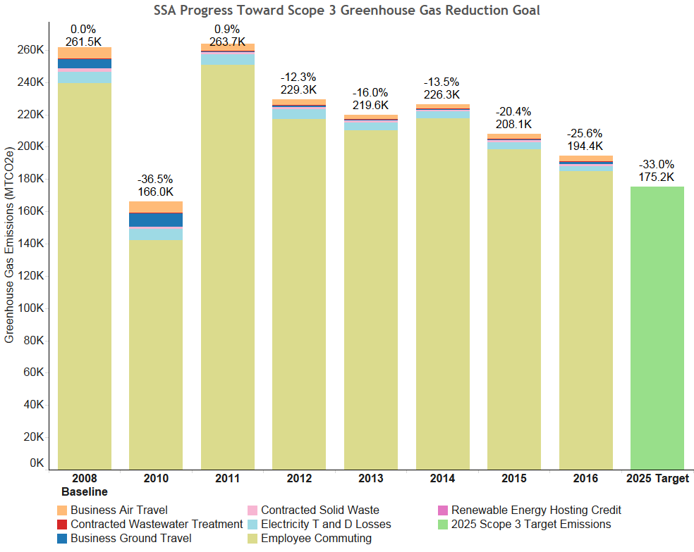
SSA’s Scope 3 emissions continued their downward trend, thanks to reduced commuting and increases in telework. SSA will continue its efforts to reduce Scope 3 emissions through the strategies outlined below.

Scope 3 GHG Reduction Strategies for Fiscal Year 2018
Strategy | Strategy Narrative | Targets and Metrics
Develop and deploy an employee commuter emissions reduction plan. | The focus of our employee commuter reduction plan is to increase telework as described below. | A continued increase in the number of employees teleworking regularly in FY 2017 and 2018.
Increase & track number of employees eligible for telework and/or the total number of days teleworked. | An agreement we reached with our unions in FY 2014 expanded the number of employees eligible for our telework program. We have seen continued increase in telework participation, and expect continued growth in the near future. | A continued increase in the number of employees teleworking regularly in FY 2017 and 2018.
Develop and implement a program to support alternative/zero emissions commuting methods and provide necessary infrastructure. | We will explore different approaches being used by other Government agencies and the private sector to provide charging infrastructure to employees, and choose the best one to pilot. | An approach to workplace charging is being evaluated in CY 2017.
Establish policies and programs to facilitate workplace charging for employee electric vehicles. | We will explore different approaches being used by other government agencies and the private sector to using fees to cover the costs of offering charging for employee vehicles, and choose the best one to pilot. | An approach to charge fees to cover the costs of offering charging for employee are being evaluated in CY 2017.

Goal 2: Sustainable Buildings

Building Energy Conservation Goal
The Energy Independence and Security Act of 2007 (EISA) required each agency to reduce energy intensity 30% by FY 2015 as compared to FY 2003 baseline. Section 3(a) of E.O. 13693 requires agencies to promote building energy conservation, efficiency, and management and reduce building energy intensity by 2.5% annually through the end of FY 2025, relative to a FY 2015 baseline and taking into account agency progress to date, except where revised pursuant to Section 9(f) of E.O. 13693.

Chart: Progress Toward Facility Energy Intensity Reduction Goal
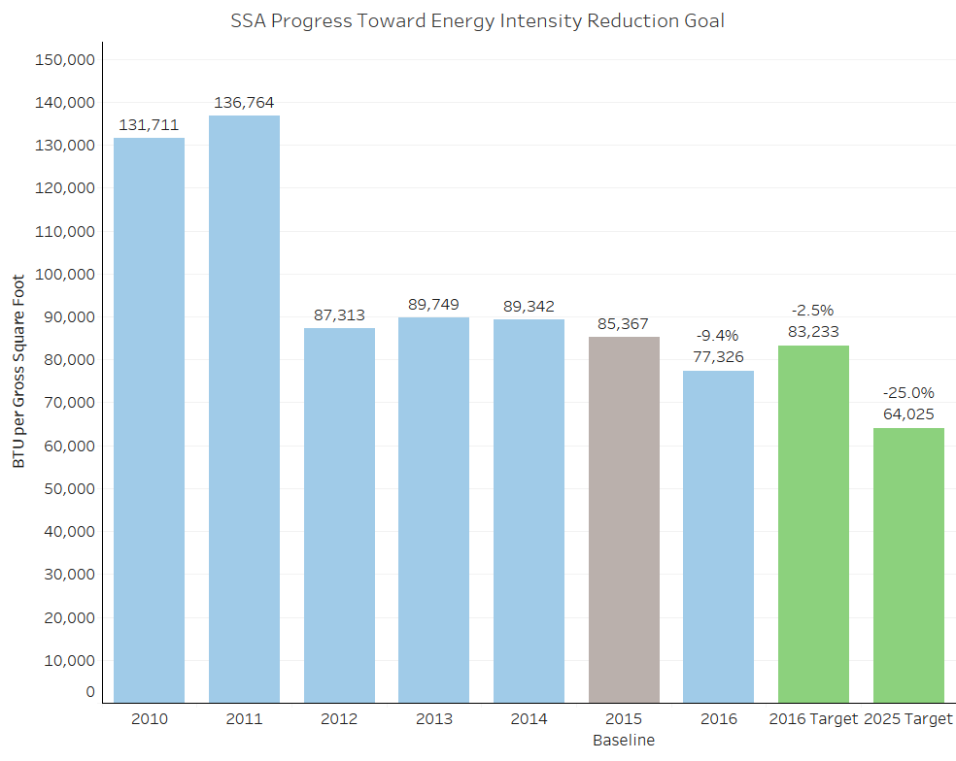
SSA is proud to have exceeded the 30 percent energy intensity reduction required by EISA for goal-subject facilities in FY 2015 compared to the FY 2003 baseline. SSA is also proud to have achieved green for energy reduction for the 2016 Scorecard and is on track to meet the 25 percent energy reduction by 2025. We will continue implementing improvements to our facilities to achieve additional energy intensity reductions.

Building Energy Conservation Strategies for Fiscal Year 2018
Strategy | Strategy Narrative | Targets and Metrics
Make energy efficiency investments in agency buildings. | We will continue to request funding to perform energy audits when due, and implement the identified measures to improve energy efficiency. | Energy intensity reduced 7.5 percent in FY 2018 from the FY 2015 baseline.
Participate in demand management programs. | The Northeastern Program Service Center participates in a demand management program during winter months. | The Northeastern Program Service Center will continue participating in a demand management program.
Install and monitor energy meters and sub-meters. | We will continue to add smart meters to identify areas where we can reduce our energy and water usage. | Energy intensity reduced 7.5 percent in FY 2018 from the FY 2015 baseline.
Collect and utilize building and facility energy use data to improve building energy management and performance. | We use and will continue to use building and facility energy use data to improve building energy management and performance. | EPA’s Energy Star Portfolio Manager used to analyze building energy management data.
Ensure that monthly performance data is entered into the EPA ENERGY STAR Portfolio Manager. | We will continue to enter monthly performance data into the EPA Energy Star Portfolio Manager System. | Performance data entered into Portfolio Manager.

Building Efficiency, Performance, and Management Goal
Section 3(h) of E.O. 13693 states that agencies will improve building efficiency, performance, and management and requires that agencies identify a percentage of the agency's existing buildings above 5,000 gross square feet intended to be energy, waste, or water net-zero buildings by FY 2025 and implementing actions that will allow those buildings to meet that target.
SSA had initially identified 54 percent of its gross square footage to use Baltimore’s waste-to-energy facility to satisfy the net zero waste goal. However, based on calculation of waste converted to energy in the Guidance of Waste Diversion Goals Credit in Federal Compliance with E.O. 13693, it will not be possible for SSA to meet net-zero goals in its delegated facilities.

Guiding Principles for Sustainable Federal Buildings
Section 3(h) of E.O. 13693 also states that agencies will identify a percentage, by number or total GSF, of existing buildings above 5,000 GSF that will comply with the Guiding Principles for Sustainable Federal Buildings (Guiding Principles) by FY 2025.
SSA’s FY 2025 target is 15 percent of total GSF of delegated facilities. Our delegated facilities comply with almost all of the Guiding Principles criteria for existing buildings. We will continue to evaluate ways to meet additional criteria so that the buildings conform with the Guiding Principles.

Sustainable Buildings Strategies for Fiscal Year 2018
SSA’s delegated facilities are all GSA leases, and SSA does not construct new buildings. Therefore, not all potential strategies apply to SSA, and only three are listed below.
Strategy | Strategy Narrative | Targets and Metrics
Include climate resilient design and management into the operation, repair, and renovation of existing agency buildings and the design of new buildings. | We include climate resilient design as part of asset planning at our facility in California (seismic retrofit) that will conform to GSA’s Seismic Requirements for Leased Buildings. | Continued assessment of climate resilient design in future asset planning.
Incorporate green building specifications into all new construction, modernization, and major renovation projects. | Any new construction, modernization, and major renovation projects performed on behalf of SSA is handled by GSA. Should any such activities occur in the future, we will work with GSA to incorporate green building specifications. | Green building specifications incorporated into any new construction and major renovation projects done for SSA by GSA, if GSA concurs.
Implement programs on occupant health and well-being in accordance with the Guiding Principles. | We have installed bottle-filling stations in buildings on the HQ campus to promote easier access to potable water and to reduce water waste and bottle recycling. | We will continue to assess the needs for additional bottle filling stations throughout the campus.

Goal 3: Clean & Renewable Energy

Clean Energy Goal
E.O. 13693 Section 3(b) requires that, at a minimum, the percentage of an agency's total electric and thermal energy accounted for by clean energy (i.e., renewable and alternative energy) shall be not less than: 10% in FY 2016-17; 13% in FY 2018-19; 16% in FY 2020-21; 20% in FY 2022-23; and 25% by FY 2025.

Chart: Use of Clean Energy as a Percentage of Total Electric Energy and Thermal Energy

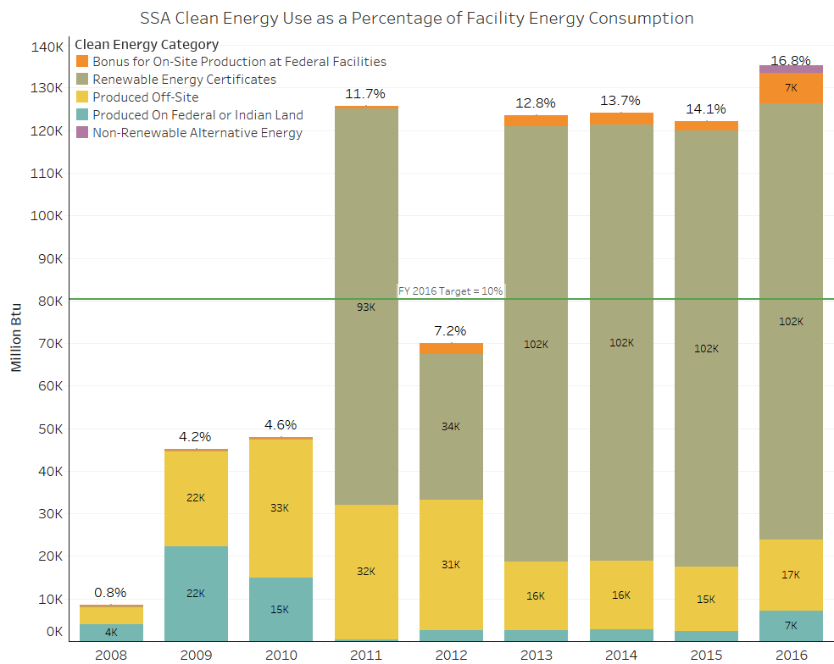

Renewable Electric Energy Goal
E.O. 13693 Section 3(c) requires that renewable energy account for not less than 10% of total electric energy consumed by an agency in FY 2016-17; 15% in FY 2018-19; 20% in FY 2020-21; 25% in FY 2022-23; and 30% by 2025.

Chart: Use of Renewable Energy as a Percentage of Total Electric Energy

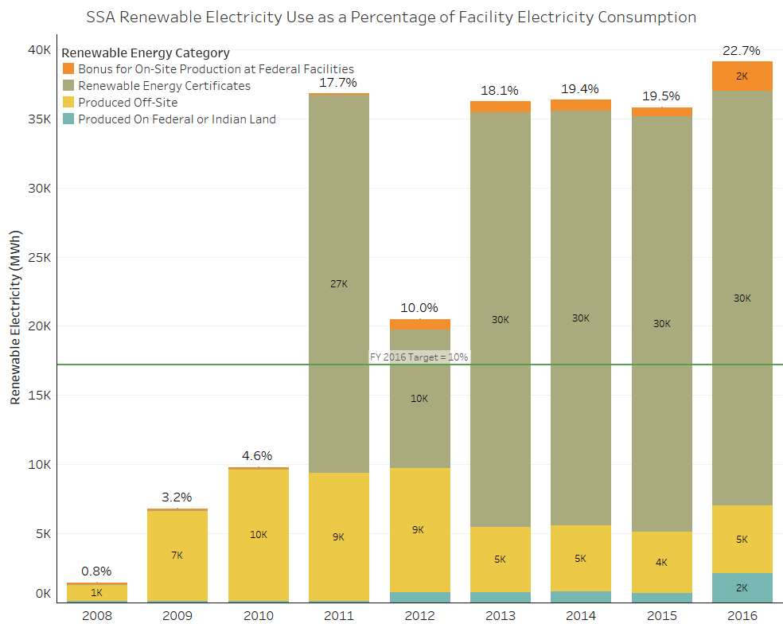
SSA is proud to have had 22.7 percent of our total electricity consumption come from renewable sources in FY 2016, exceeding the goal of 10 percent. However, due to lack of funding, infeasibility, and extremely long return on investment values for on-site renewable projects, SSA will not use between 4 and 7 of the strategies the table below.

Clean and Renewable Energy Strategies for Fiscal Year 2018
Strategy | Strategy Narrative | Targets and Metrics
Install on-site combined heat and power processes. | Following discussions on combined heat and power at our energy meetings, we will move forward with a CHP design in FY 2018. | Begin design of new SSA CHP facility.
Purchase electricity and corresponding RECs or obtain equal value replacement RECs. | We include green energy purchases (electricity from renewable sources plus the associated RECs) as part of our electricity purchases to meet annual targets for renewable energy. As electrical contracts expire, we will continue to purchase electricity and their associated RECs. | Continued purchase of electricity and associated RECs via GSA.

Goal 4: Water Use Efficiency & Management

Potable Water Consumption Intensity Goal
E.O. 13693 Section 3(f) states that agencies must improve water use efficiency and management, including stormwater management, and requires agencies to reduce potable water consumption intensity, measured in gallons per square foot, by 2% annually through FY 2025 relative to an FY 2007 baseline. A 36% reduction is required by FY 2025.

Industrial, Landscaping and Agricultural (ILA) Water Goal
E.O. 13693 section 3(f) also requires that agencies reduce ILA water consumption, measured in gallons, by 2% annually through FY 2025 relative to a FY 2010 baseline.

Chart: Progress Toward the Potable Water Intensity Reduction Goal
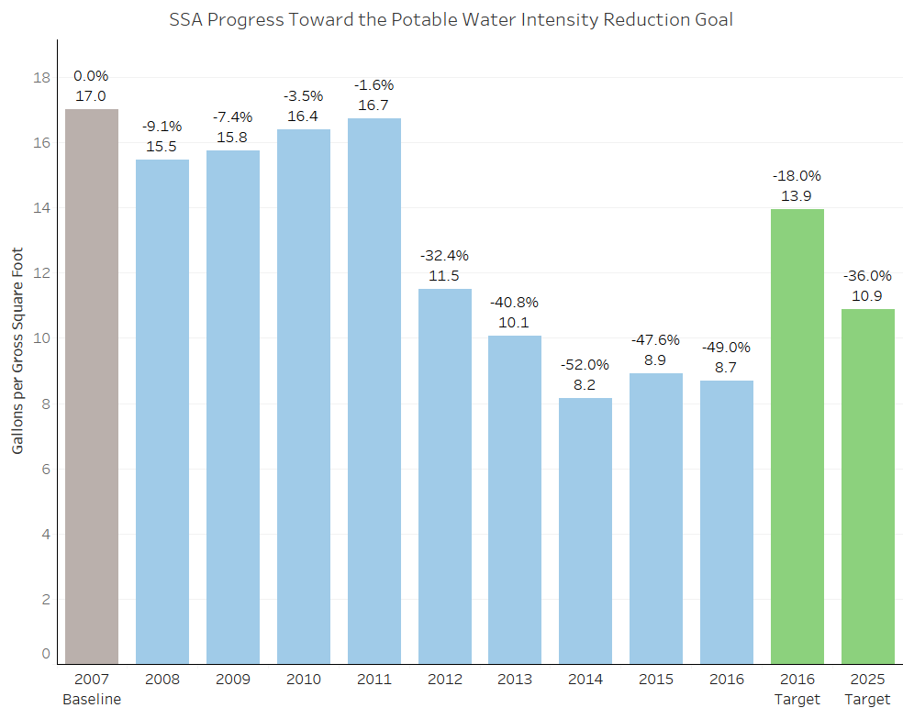
SSA is proud to have exceeded the FY 2016 potable water intensity goal of 18 percent reduction achieving a 49 percent reduction against the FY 2007 baseline. We will continue to evaluate opportunities to increase our water usage efficiency.

Water Use Efficiency & Management Strategies for Fiscal Year 2018
Strategy | Strategy Narrative | Targets and Metrics
Install and monitor water meters and utilize data to advance water conservation and management. | We have installed water metering for irrigation and potable water use. We are performing advanced metering studies with GSA to determine if additional smart meters are required. | Potable water intensity reduced by at least 20 percent in FY 2017 and 22 percent in FY 2018 from the FY 2007 baseline
Prepare and implement a water asset management plan to maintain desired level of service at lowest life cycle cost. | Our current operations and maintenance program continues to use a water asset management plan to maintain desired level of service at lowest life cycle cost. | Potable water intensity reduced by at least 20 percent in FY 2017 and 22 percent in FY 2018 from the FY 2007 baseline.
Minimize outdoor water use and use alternative water sources as much as possible. | We reclaim condensate water, ground water seepage, and rainwater for reuse as gray water and landscaping irrigation at our Harold Washington Social Security Center and Western Program Service Center. At HQ, we have water sensors as part of our irrigation system and only irrigate the lawns in the front of the facility. | Potable water intensity reduced by at least 20 percent in FY 2017 and 22 percent in FY 2018 from the FY 2007 baseline.
Install advanced meters to measure and monitor potable and ILA water use. | We have already installed water metering for irrigation and potable water use. However, we are performing advanced metering studies to determine if any additional meters can be beneficial. We do not have any agricultural or industrial water use. | ILA water intensity reduced by at least 14 percent in FY 2017 and 16 percent in FY 2018 from FY 2010 baseline.
Ensure that planned energy efficiency improvements consider associated opportunities for water conservation. | As we plan energy efficiency improvements, we always consider opportunities for water conservation. | Potable water intensity reduced by at least 20 percent in FY 2017 and 22 percent in FY 2018 from the FY 2007 baseline.

Goal 5: Fleet Management

Fleet Per-Mile Greenhouse Gas (GHG) Emissions Goal
E.O. 13693 Section 3(g) states that agencies with a fleet of at least 20 motor vehicles will improve fleet and vehicle efficiency and management. E.O. 13693 section 3(g)(ii) requires agencies to reduce fleet-wide per-mile GHG emissions from agency fleet vehicles relative to a FY 2014 baseline and sets new goals for percentage reductions: not less than 4% by FY 2017; not less than 15 % by FY 2020; and not less than 30% by FY 2025.
E.O. 13693 Section 3(g)(i) requires that agencies determine the optimum fleet inventory, emphasizing eliminating unnecessary or non-essential vehicles. The Fleet Management Plan and Vehicle Allocation Methodology (VAM) Report are included as appendices to this plan.
Chart: Fleet-wide Per-mile GHG Emissions
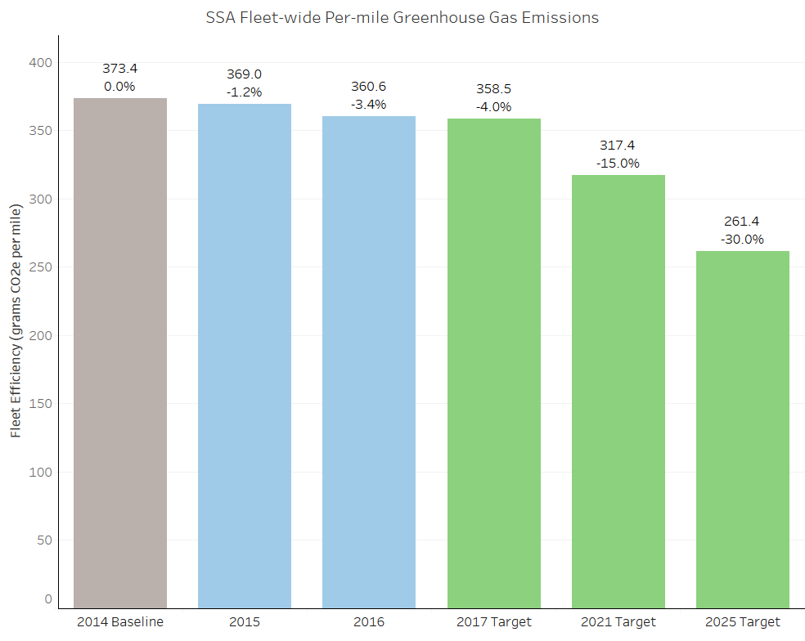

Fleet Alternative Fuel Consumption Goal
The Energy Independence and Security Act 2007 (EISA) requires that, not later than October 1, 2015 and each year thereafter, that each Federal agency achieve a 10 percent increase in annual alternative fuel consumption, compared to a FY 2005 baseline. By FY 2016, agencies were to have increased alternative fuel use by 175.3% relative to FY 2005. In addition, OMB has asked all agencies to achieve a minimum of 5% alternative fuel use of their total fuel consumption.
In FY 2016, SSA’s use of alternative fuel equaled 13.9 percent of total fuel use. SSA has increased its alternative fuel use by 1,384 percent since FY 2005.
SSA is currently meeting all required goals of Executive Order 13693 (Planning for Federal Sustainability in the Next Decade) and the 2007 Energy Independence and Security Act (EISA Section 141). We intend to continue meeting those requirements through a strategy that incorporates acquiring the right types of vehicles, maximizing the use of alternative fuel, and using telematics.
In FY 2016, we began acquiring low GHG vehicles to the maximum extent possible. We have strategically placed all newly acquired vehicles in areas with supporting fuel type infrastructures. All vehicles located within 5 miles or 15 minutes of an E85 fueling station will receive an E85 capable flex fuel vehicle. Vehicles outside of the E85 radius will receive a low GHG dedicated gasoline vehicle. We have had huge successes with our alternative fuel use, thanks to the agency-owned E85 tank at SSA HQ. Twenty percent of the agency’s vehicles are located at the HQ, which enables us to maximize the use of E85, because many field locations have limited access to E85. Since the beginning of FY 2017, we have taken additional steps to improve the use of E85 in our field locations, including publishing an Alternative Fuel Use and Missed Opportunity Report to our field offices. This report identifies vehicles that had an opportunity to fuel with E85 and did not. Within the first two months of issuing the report, we saw a decrease in missed opportunities of 1.5 percent. Telematics installation started in FY 2016 and will continue through FY 2018 as new vehicles are acquired. Starting in FY18, we will analyze vehicle idling data. Reducing idling time by 15 minutes per day per vehicle could save the agency approximately 600 gallons of fuel per year. In addition, in FY18 we will start identifying vehicles that do not meet the vehicle manufacturer’s recommended MPG within a variable of 12% to help us identify vehicles that are the most efficient for our fleet.

Fleet Management Strategies for Fiscal Year 2018
Strategy | Strategy Narrative | Targets and Metrics
Collect and utilize agency fleet operational data through deployment of vehicle telematics and implement vehicle idle mitigation technologies. | We will begin analyzing data collected from the telematics system, such as vehicles with excessive idling time, and continue installing vehicle telematics in new acquisitions of light-duty vehicles in FY 2018. We will continue to procure vehicles with Automatic Start Stop systems. | In FY 2018, begin analyzing vehicle idling data to look for opportunities to reduce vehicle idling time versus engine run time. In FY 2018, identify vehicles that do not meet the vehicle manufacture’s recommended MPG, within a variable of 12 percent.
Ensure that agency annual asset-level fleet data is properly and accurately accounted for in a formal Fleet Management Information System as well as submitted to the Federal Automotive Statistical Tool reporting database, the Federal Motor Vehicle Registration System, and the Fleet Sustainability Dashboard (FLEETDASH) system. | Our primary FMIS is GSA’s Fleet Drive Thru and FED FMS system that enables us to feed data into the Federal Automotive Statistical Tool (FAST), Federal Motor Vehicle Registration System (FMVRS), as well as FLEETDASH. | Verification that data is properly entered into FAST, FLEETDASH, and FMVRS.
Increase acquisitions of zero emission and plug-in hybrid vehicles. | We procured six PHEV’s in FY 2017 and will continue to procure them, when feasible. | Initial target is 30 percent of new acquisitions to be EV’s or PHEV’s by FY 2020.
Optimize and right-size fleet composition, by reducing vehicle size, eliminating underutilized vehicles, and acquiring and locating vehicles to match local fuel infrastructure. | We regularly review our mission needs and vehicle utilization to right size our fleet and will continue to do so through vehicle utilization surveys and quarterly meetings with our Fleet Liaisons. We have reduced our fleet from 534 to 451 vehicles since 2005, an 18 percent reduction. | Use Alternative Fueling Station Locator system to ensure 100 percent of FY 2018 new vehicle acquisitions match local fuel infrastructure availability.
Increase utilization of alternative fuel in dual-fuel vehicles. | We implemented a monthly missed opportunity report and fuel usage report to identify vehicles that could have used E-85 flex fuel. | Increase the use of E-85 flex-fuel from 14 percent in FY 2016 to 20 percent in FY 2018.
Minimize use of law enforcement exemptions by implementing GSA Bulletin FMR B-33, Motor Vehicle Management, Alternative Fuel Vehicle Guidance for Law Enforcement and Emergency Vehicle Fleets. | We classified most of our LE vehicles as Category II vehicles and will continue to procure Category II, Low GHG vehicles, and Alternative Fuel vehicles in FY 2018. 100 percent of all new LE acquisitions are Category II vehicles. To date, we have not exempted any LE II vehicles from our reporting requirements. | Currently have 2 LE I vehicles with an LE exemption. Any additional exempt vehicles will be accounted for.
Establish policy/plan to reduce miles traveled, e.g. through vehicle sharing, improving routing with telematics, eliminating trips, improving scheduling, and using shuttles, etc. | We established a robust shuttle system between our HQ facilities and for regional employees visiting HQ, which precludes unnecessary travel by Government employees between facilities and the need for rental cars for visiting employees. In addition, we collaborated with the Center for Medicare and Medicaid Services to provide a ride sharing service between our offices in Baltimore and Metropolitan D.C. areas. | Petroleum based fuel used by the agency’s fleet reduced by at least 25 percent from 2005 baseline.

Goal 6: Sustainable Acquisition

Sustainable Acquisition Goal
E.O. 13693 section 3(i) requires agencies to promote sustainable acquisition by ensuring that environmental performance and sustainability factors are considered to the maximum extent practicable for all applicable procurements in the planning, award and execution phases of acquisition.

Biobased Purchasing Targets
The Agricultural Act of 2014 (Public Law 113-79) amends Section 9002 (a)(2)(A)(i) of the Farm Security and Rural Investment Act of 2002 to establish a targeted biobased-only procurement requirement under which the procuring agency shall issue a certain number of biobased-only contracts when the procuring agency is purchasing products, or purchasing services that include the use of products, that are included in a biobased product category. Therefore agencies are to establish an annual target for increasing the number of contracts to be awarded with BioPreferred and biobased criteria and the dollar value of BioPreferred and biobased products to be delivered and reported under those contracts in the following fiscal year.
For FY 2018, SSA has established a target of 21 contracts and $4,143,000 in biobased products to be delivered.

Chart: Percent of Applicable Contracts Containing Sustainable Acquisition Requirements
Percent of Applicable Contracts Containing Sustainable Acquisition Requirements

# of Contracts Reviewed | Percentage Compliant
53 | 100.0%
Based on agency-reported results of quarterly reviews of at least 5% of applicable contract actions.
SSA provides agency-specific sustainable acquisition policy in our Acquisition Handbook, Green Purchasing Plan, and Micro-purchasing manual. We issue quarterly reminders and hold bi-monthly and quarterly forums to educate contract-related staff about their sustainable acquisition roles and responsibilities. We are in the process of updating our sustainable acquisition policy and await the appointment and confirmation of our new Commissioner to complete these updates.

Sustainable Acquisition Strategies for Fiscal Year 2018
Strategy | Strategy Narrative | Targets and Metrics
Establish and implement policies to meet statutory mandates requiring purchasing preference for recycled content products, ENERGY STAR qualified and FEMP-designated products, and BioPreferred and biobased products designated by USDA. | We currently meet statutory mandates requiring purchase preference for recycled content products, Energy Star® qualified and FEMP-designated products, and Biopreferred and biobased products designated by USDA and will continue to do so. We include the applicable Federal Acquisition Regulation (FAR) policy and clause prescriptions in our Green Purchasing Plan (Plan). We ensure appropriate FAR clause inclusion during quarterly sustainable acquisition reviews and semi-annual acquisition management reviews. | Conduct quarterly sustainable acquisition reviews and  semi-annual acquisition management reviews through June 2018.
Establish and implement policies to purchase sustainable products and services identified by EPA programs, including SNAP, WaterSense, Safer Choice, and Smart Way. | We currently require purchasing preference for sustainable products and services identified by EPA programs, including SNAP and WaterSense, and we will continue to do so. We include applicable FAR policy and clause prescriptions in our Plan. We ensure appropriate FAR clause inclusion during quarterly sustainable acquisition reviews and semi-annual acquisition management reviews. We will update our Plan to include Safer Choice labeled and Smart Way transport partners in sustainable products and services. | - Conduct quarterly sustainable acquisition reviews and semi-annual acquisition management reviews through June 2018; and  - Update Plan when our new SSA Commissioner is confirmed. Updates to the Plan will be announced, and the Plan re-introduced through targeted training upon revision.
Establish and implement policies to purchase environmentally preferable products and services that meet or exceed specifications, standards, or labels recommended by EPA. | We will continue to focus on improving the procurement of environmentally preferable products and services that meet or exceed specifications, standards, or labels recommended by EPA by referring to EPA’s Recommendations of Specifications, Standards, and Ecolabels for Federal Purchasing. | Update Plan when our new SSA Commissioner is confirmed. Announce updates to the Plan, and re-introduce the Plan through targeted training upon revision.
Use Category Management Initiatives and government-wide acquisition vehicles that already include sustainable acquisition criteria. | We require contracting staff and micro-purchasers to consider sustainable office supplies from IDIQ contracts with the Federal Strategic Sourcing Initiatives before procuring items from any other source. We require micro-purchasers to document their acquisition files when they do not purchase an item available from FSSIs. We encourage the use of the IT, office management, and facilities and construction category management initiatives that include sustainable acquisition criteria. Agency staff adheres to OMB and Office of Federal Procurement Policy Category Management Policy Directive, 15-1, by adopting standardized laptop and desktop configurations, mandating purchases from existing vehicles, and adopting smarter business practices. | - Update Plan to include sustainable acquisition criteria category management and strategic sourcing policy when our new SSA commissioner is confirmed;  - Announce updates to the Plan, and re-introduce the Plan through targeted training upon revision;  - Continue to issue quarterly reminders; and  - Provide targeted training.
Identify and implement corrective actions to address barriers to increasing sustainable acquisitions. | We will continue to address barriers to increasing sustainable acquisition by training agency contracting staff and discussing corrective actions found during quarterly sustainable acquisition reviews and semi-annual acquisition management reviews. | Conduct training and discuss corrective actions through June 2018 during: (1) quarterly sustainable acquisition reviews; (2) semi-annual acquisition management reviews; (4) quarterly reminders; and (3) targeted sustainable acquisition training.
Incorporate compliance with contract sustainability requirements into procedures for monitoring contractor past performance and report on contractor compliance in performance reviews. | We issue regular Contractor  Performance Assessment Reporting System (CPARS) reminders, including sustainability requirements evaluation, to contracting staff. FAR Case 2014-010, effective June 8, 2015, employed the evaluation of sustainability compliance in contractor performance reviews. We follow the FAR guidance and will continue to report sustainability compliance in CPARS. We further supplement the FAR guidance by instructing contracting staff to include sustainability requirements evaluation in our agency-specific CPARS Policy Guide and acquisition policy Handbook. | Update the Plan to include sustainability compliance as an assessment factor when our new SSA Commissioner is confirmed; and announce updates to the Plan, and re-introduce the Plan through targeted training upon revision.

Goal 7: Pollution Prevention & Waste Reduction

Pollution Prevention & Waste Reduction Goal
E.O. 13693 section 3(j) requires that Federal agencies advance waste prevention and pollution prevention and to annually divert at least 50% of non-hazardous construction and demolition debris. Section 3(j)(ii) further requires agencies to divert at least 50% of non-hazardous solid waste, including food and compostable material, and to pursue opportunities for net-zero waste or additional diversion.

Chart: Waste Diversion
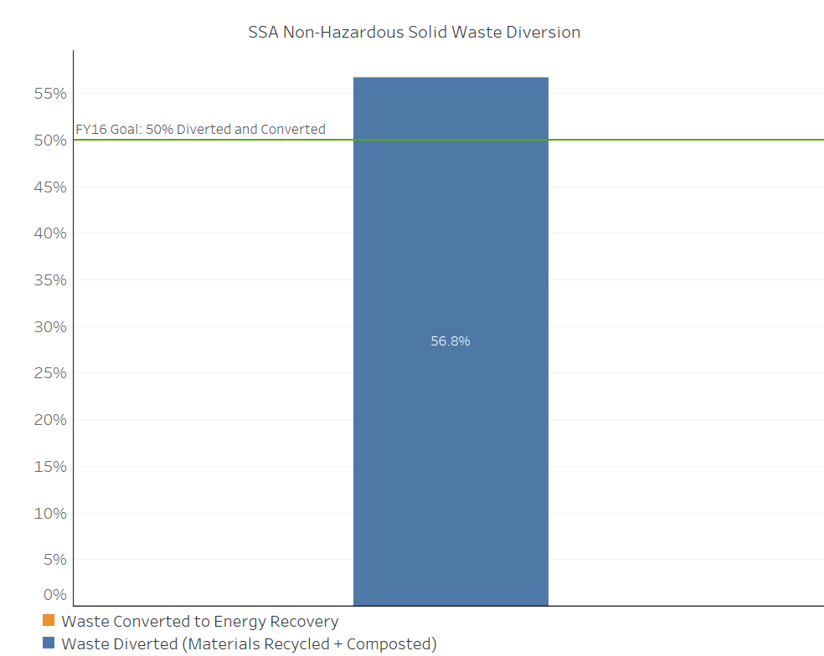
SSA is proud to have diverted 56.8 percent of its total annual waste from landfills in FY 2016, exceeding the goal of 50 percent.

Pollution Prevention & Waste Reduction Strategies for Fiscal Year 2018
Strategy | Strategy Narrative | Targets and Metrics
Report in accordance with the requirements of sections 301 through 313 of the Emergency Planning and Community Right-to-Know Act of 1986 (42 U.S.C 11001-11023). | In 2017, we were in full compliance with all Emergency Planning and Community Right-to-Know Act reporting requirements, and will continue to report as required. | Report as required for 2018.
Reduce or minimize the quantity of toxic and hazardous chemicals acquired, used, or disposed of, particularly where such reduction will assist the agency in pursuing agency greenhouse gas reduction targets. | We developed a waste minimization and chemical storage plan to reduce the quantity of chemicals used at the HQ campus. We developed a waste minimization workgroup to improve chemical purchasing, storage, and minimization strategies. | Conduct baseline surveys and chemical inventories to dispose of unneeded products to help with storage and minimization strategies in FY 2018.
Eliminate, reduce, or recover refrigerants and other fugitive emissions. | We use refrigerant recovery systems at all of our delegated facilities. We will continue to track fugitive emissions and make changes and repairs as necessary. | Report emissions of HFCs in the FY 2017 and FY 2018 SSA GHG inventory.
Reduce waste generation through elimination, source reduction, and recycling. | We will continue to research additional ways to increase our recycling. | Divert a minimum of 50 percent of non-hazardous solid waste in FY 2017 and FY 2018.
Implement integrated pest management and improved landscape management practices to reduce and eliminate the use of toxic and hazardous chemicals and materials. | We continue to require pest control contractors to implement Integrated Pest Management practices and will continue to review all relevant agency contracts to ensure they include language requiring the proper implementation of pest management. | Continue the efforts of the Integrated Pest Management practices in FY 2018.
Develop or revise Agency Chemicals Inventory Plans and identify and deploy chemical elimination, substitution, and/or management opportunities. | We have developed a waste minimization and chemical storage plan to reduce the quantity of chemicals used at the HQ campus. We have also formed a chemical safety committee to identify redundant chemicals, reduce hazardous chemicals, and improve purchasing practices. | Continue the chemical safety committee through FY 2018.
Inventory current HFC use and purchases, and ensure HFC management training and recycling equipment are available. | We will continue to inventory HFC use and purchases, and all new contracts that involve HFCs will include a requirement for the contractor to provide quantities of HFCs used. We mandate training on the use of recycling equipment for all HVAC and contract personnel, both in house and contractors. We will ensure that such training is part of any new contracts that involve HFCs. | Continue to annually inventory HFC use and purchases. Provide training to all new HVAC employees on the use of recycling equipment.

Goal 8: Energy Performance Contracts

Performance Contracting Goal
E.O. 13693 section 3(k) requires that agencies implement performance contracts for Federal buildings. E.O. 13693 section 3(k)(iii) also requires that agencies provide annual agency targets for performance contracting. SSA’s targets for the next two fiscal years are:
FY 2018: $ 11,000,000
FY 2019: $ 0

SSA’s FY 18 energy performance contracts target is approximately $11 million, via a proposed UESC performance contract (July 2017) in the Frank Hagel Federal Building (FHFB) in Richmond, California. This contract includes installing 2 energy efficient chillers ($7 million) and 10 energy efficient air handler units ($4 million). We exceeded our $20 million pledge under the Presidential Performance Contracting Challenge by the end of 2016 and have already exceeded the recommended total cumulative agency performance contracting commitments set forth in the EO 13693 Implementing Instructions. The total cumulative commitment from the agency is $49.2 million (from 20212 through 2018) so far, greatly exceeding the $16.6 million FY 2018 guideline commitment. Included in our $49.2 million in commitments is $17.8 million in performance contracts at our Harold Washington Social Security Center in Chicago, Illinois, where construction will start in FY 2017, and $20.4 million previously awarded at our HQ facilities from 2012 to 2016. There is no target set for FY 2019 because we have already reached our goals, but we are planning to begin design on a combined heat and power plant in 2018, which would be constructed between 2019 and 2021, and presents opportunities for additional performance contracts.

Chart: Progress Toward Target under the 2016 Performance Contracting Challenge
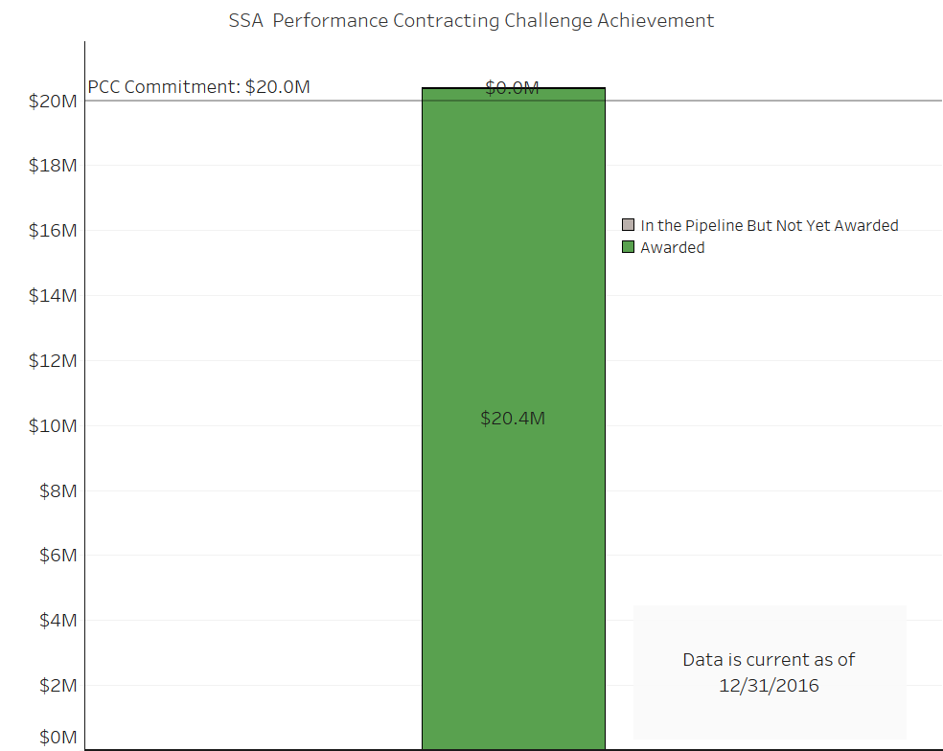
SSA’s commitment under the President’s Performance Contracting Challenge is $20 million in contracts, all of which was awarded prior to the end of calendar year 2016.

Performance Contracting Strategies for Fiscal Year 2018
Strategy | Strategy Narrative | Targets and Metrics
Utilize performance contracting and incorporate use of ESPCs and UESCs into planning activities to meet identified energy & water efficiency and Administration objectives while deploying life-cycle cost effective infrastructure projects, with clean energy technology, energy and water & other savings measures. | We plan to use a UESC contract to replace major HVAC equipment at our Frank Hagel Federal Building in Richmond, California. Tentative award in FY 17 2 with construction in FY 18/FY 19 | Energy intensity reduced 7.5 percent in FY 2018 from the FY 2015 baseline (2.5 annual reduction x 3 years).
Evaluate the top 25% of agency's most energy intensive buildings for opportunities to implement comprehensive ESPC/UESC projects. | We complete energy audits as required by EISA §432. We use multiple procurement methods to award contracts to implement energy efficiency measures, including ESPCs and direct funding. | Energy audits completed as required under EISA §432.
Identify potential onsite renewable energy projects in a specified percentage of performance contracts. | All future performance-based contracts for SSA-delegated facilities will evaluate the potential for renewable energy. | All future performance-based contracts for SSA-delegated facilities will evaluate the potential for renewable energy.

Goal 9: Electronics Stewardship & Data Centers

Electronics Stewardship Goals
E.O. 13693 Section 3(l) requires that agencies promote electronics stewardship, including procurement preference for environmentally sustainable electronic products; establishing and implementing policies to enable power management, duplex printing, and other energy efficient or environmentally sustainable features on all eligible agency electronic products; and employing environmentally sound practices with respect to the agency's disposition of all agency excess or surplus electronic products.

Agency Progress in Meeting Electronics Stewardship Goals

Chart: Insert chart(s) on progress towards procurement goal, power management goal, and end of life goal
Electronics Stewardship
EPEAT | POWER MANAGEMENT | DISPOSITION
Percentage of monitors, PCs and laptops acquired by the agency that meet EPEAT-registry standards  100.0% | Percentage of monitors, PCs and laptops with power management-enabled  100.0% | Percentage of agency electronics disposed of using environmentally sound methods^{1,2}  100.0%*
*Agency Targets: 100% for all three categories. Green shading indicates achievement of 95% target for EPEAT and 100% target for Power Management and Disposition. Yellow indicates greater than 90% achievement, and red indicates less than 90%. See more information about data sources in the Implementing Instructions, page 64.
¹Disposition: Percentage based on agency Annual Executive Agency Reports on Excess and Exchange/Sale Personal Property (FMR B-27).
² Environmentally sound methods include: reuse through transfer, donation, and sales; and recycling through certified recyclers and manufacturer take-back programs using certified recyclers.

Data Center Optimization Goal
E.O. 13693 Section 3(a) states that agencies must improve data center efficiency at agency facilities, and requires that agencies establish a power usage effectiveness target in the range of 1.2-1.4 for new data centers and less than 1.5 for existing data centers.

Electronics Stewardship Strategies for Fiscal Year 2018
Strategy | Strategy Narrative | Targets and Metrics
Use government-wide category management vehicles to ensure procurement of equipment that meets sustainable electronics criteria. | We directed agency contracting staff to adhere to Office of Management and Budget and Office of Federal Procurement Policy Category Management Policy Directive, 15-1, by adopting standardized laptop and desktop configurations, mandating purchases from existing vehicles, and adopting smarter business practices. | - Update the Plan to include information technology category management policy when our new SSA commissioner is confirmed;  - Announce updates to the Plan and reintroduce the Plan through targeted training upon revision;  - Continue to issue quarterly reminders; and  - Provide targeted training.
Enable and maintain power management on all eligible electronics; measure and report compliance. | We scored green in all electronic stewardship areas, with at least 95 percent of purchased monitors and computers compliant with the Electronic Product Environmental Assessment Tool (EPEAT). | We will continue to ensure that at least 99 percent of purchased desktop computers, laptops, and monitors are rated Silver or better by EPEAT, and that 100 percent are Energy Star or EPEAT-registered and will ensure compliance via quarterly green procurement compliance reviews.
Implement automatic duplexing and other print management features on all eligible agency computers and imaging equipment; measure and report compliance. | Power management is enabled on all computers and monitors. | To ensure our continued use of power management features on all desktop and laptop computers, SIIMS will continue to use our comprehensive reporting and auditing compliance system.
Ensure environmentally sound disposition of all agency excess and surplus electronics, consistent with Federal policies on recycling & disposal of electronic assets, and measure and report compliance. | The Division of Property Management (DPM) continues to dispose of all end-life-electronics in accordance with GSA and FMR, through Computers for Learning (CFL), Direct Transfers to Federal Agencies, State Agency for Surplus Property (SASP), certified (R2 or e-steward) recyclers, and GSAXcess / GOV-Sales. DPM also manages a Memorandum of Understanding with the United States Postal Service (USPS) for disposing of qualified electronics in remote locations and a hard drive and portable device sanitization services contract to safeguard PII for SSA. | DPM will continue to establish and implement property management policies and guidance to SSA Property Management Officers and Custodial Officers nationwide to promote and continuously achieve environmentally sound disposition of 100 percent of agency excess electronic products.
Work with CIO counterparts to improve tracking and reporting systems for electronics stewardship requirements throughout lifecycle. | All end-of-life electronics disposed are through GSA Xcess, Computers for Learning (CFL), Unicor, or certified recyclers. | SIIMS ensures the environmentally sound disposal of all excess or surplus electronic products on an ongoing basis through the policies and procedures, which only allow disposition through GSA Xcess, CFL, Unicor, or a certified recycler.

Data Center Optimization Strategies for Fiscal Year 2018
Strategy | Strategy Narrative | Targets and Metrics
Develop, issue and implement policies, procedures and guidance for data center energy optimization, efficiency, and performance. | SSA is currently developing a Data Center Optimization Management (DCOM) strategy that conforms to current Federal IT Acquisition Reform Act /Data Center Optimization Initiative requirements. | - Energy Metering 100 percent  - PUE ≤ 1.4  - Virtualization ≥ 4  - Server Utilization & Automated Monitoring ≥ 65 percent  - Facility Utilization ≥ 80 percent
Minimize total cost of ownership in data center and cloud computing operations. | By continuing to consolidate, virtualize, and offer cloud services, both internally and externally, we aim to maximize our data center energy efficiencies. The more equipment and digital services we can offer, the more efficiently the energy systems will operate generating energy savings and carbon neutral operations. | We are actively engaged in developing internal and external cloud services. We are developing chargeback and showback reporting that will allow us to better manage our IT and electrical consumption. The ultimate goal is to offer cloud services to other Federal Departments and agencies, which will further allow us to maximize data center space and optimize energy consumption.
Improve data center temperature and air-flow management to capture energy savings. | As our Office of Systems increases the amount of hardware and processing in the data center, they will work with the Office of Facilities and Logistics Management to optimize air-flow management by increasing inlet temperatures and maturing our convergent monitoring capabilities. | We hope to increase inlet temperatures up to ASHRAE suggested optimal ranges ~78° as well as reducing our PUE as much as possible. Our aim is 1.4 or better.
Assign certified Data Center Energy Practitioner(s) to manage core data center(s). | Continue with our Data Center Optimization Management (DCOM) strategy that relies on Systems, Facilities and Security to manage and monitor holistically our data center operations. | Continue with our regular DCOM meetings that is a collaborative effort with Systems, Facilities and Security. The goal is to achieve the above mentioned metrics.

Goal 10: Climate Change Adaptation and Resilience
E.O. 13653, Preparing the United States for the Impacts of Climate Change, outlines Federal agency responsibilities to modernize Federal programs to support climate resilient investment; manage lands and waters for climate preparedness and resilience; provide information, data and tools for climate change preparedness and resilience; and strategically plan for climate change related risk. E.O. 13653 requires agencies to develop, implement, and regularly update Adaptation Plans, and report on progress on those plans through their annual Strategic Sustainability Performance Plans.
E.O. 13693 Section 3(h)(viii) states that as part of building efficiency, performance, and management, agencies should incorporate climate-resilient design and management elements into the operation, repair, and renovation of existing agency buildings and the design of new agency buildings. Section 13(a) requires agencies to identify and address projected impacts of climate change on mission critical water, energy, communication, and transportation demands and consider those climate impacts in operational preparedness planning for major agency facilities and operations. Section 13(b) requires agencies to calculate the potential cost and risk to mission associated with agency operations that do not take into account such information and consider that cost in agency decision-making.
SSA Narrative:
As identified in last year's SSPP and the Survey on Climate Adaptation Plan, many of the contingencies and necessities for the SSA's resilience to climate change effects are covered by our Continuity of Operations Plans (COOP). These plans cover each individual site for which SSA has been delegated responsibility by GSA (which leases all SSA buildings). We have determined that the COOPs address all threats and hazards, including weather-related problems, fire emergencies, and diseases that are pandemic, infectious, and/or communicable. Our 2014 site survey identified flooding as a concern for five out six facilities; therefore, we plan to ensure that we have the latest understanding of the flood risk by consulting the latest Flood Insurance Rate Maps (floodplain maps) available from the Federal Emergency Management Agency (FEMA) for all delegated facilities where flooding could potentially occur. We plan to complete this in FY 2018. We will ensure that our staff at HQ and other delegated facilities review their COOPs and other relevant plans according to their annual review cycles and update them, as needed, to ensure that they remain current as changes to the operational environment occur or are anticipated to occur, including due to climate change. As stated in our strategies, continuity of web-based services is critical to our resiliency in the face of challenges presented by climate change. Our COOPs address these concerns for all our facilities, and the reliability is assessed with each review of the COOPs. During FY 2018, staff at HQ plans to provide additional information on climate change risk, specific to flood vulnerability, so that facilities may better utilize previously provided guidance on how to conduct climate change vulnerability and risk assessments. We will use GSA's Sustainable Facilities Tool's adaptation planning module following the release of the next National Climate Assessment, which has not yet been scheduled, but was expected to be in 2018 or 2019.

Climate Change Adaptation and Resilience Strategies for Fiscal Year 2018
Strategy | Strategy Narrative | Targets and Metrics
Update and strengthen agency internal mission, programs, policies, and operations to align with the Guiding Principles, including facility acquisition, planning, design, training, and asset management processes, to incentivize planning for and addressing the impacts of climate change. | Our COOPs address all threats and hazards, so whatever the nature of the disruption might be, the plan addresses how to deal with it. The Deputy Commissioner of each Component is responsible for ensuring that the Component, as well as all subordinate Components—at the level of the Associate Commissioner, Regional Offices, and Field Offices—review and update their COOP annually. OSEP provides the Components with a template for preparing their COOP. Regarding climate change considerations, our Office of Security Preparedness assures us that COOPs address all threats and all hazards, including climate change. | Review all COOPs and other relevant contingency plans according to their review cycle and updated as needed.
Evaluate flood risks at delegated facilities, including increased risk due to climate change impacts. | We plan to evaluate FEMA floodplain maps to make sure we use the best possible baseline for determining flooding risks. We know the facility in Jamaica, NY on Long Island is at risk, since it has experienced flooding in the past. We will evaluate the risk for all relevant facilities, including an analysis of facilities currently in 500-year flood zones. | All delegated facilities evaluated for flood risk in FY 2018.
Ensure that vulnerable populations potentially impacted by climate change are engaged in agency processes to identify measures addressing relevant climate change impacts. | We already make our services available online so customers with mobility or health issues can obtain the assistance they need without visiting one of our field offices. We have provisions in place to ensure the continuity of web-based services in the event of disruptions to the electricity grid. | Continuity of web-based services assured on an ongoing basis, in the event of disruptions to the electricity grid.
Aid delegated facilities in assessing risk due to climate change and provide guidance for them to update their COOPs accordingly. | During FY 2018, staff at HQ plans to provide additional information on climate change risk, specific to flood vulnerability, so that facilities may better utilize previously provided guidance on how to conduct climate change vulnerability and risk assessments. Appendix C of the SSA FY14 Climate Change Adaptation Plan already lays out how to conduct a vulnerability and risk assessment. HQ staff will send each facility the projected impacts relevant for their area, and explain the process for assessing vulnerabilities and risks and prioritizing issues, as per Appendix C. For those facilities wanting it, staff at HQ will set up teleconferences to guide them through the assessment process. | Flood risk analysis provided to SSA facilities following FY 2018 analysis. CCAP Appendix C will be updated, if necessary, to clarify for the facilities what must be accomplished with their climate change vulnerability risk assessment.

This is the only chart that will include progress through 12/31/2016 versus FY16 performance.

